WAZUH SOC LAB WITH PFSENSE. FULL BUILD & INTEGRATION GUIDE

OBJECTIVE
Build a full SOC lab where:
- pfSense acts as a firewall + router
- Kali is the attacker
- Windows & Ubuntu are victims
- Wazuh collects logs and shows alerts in a dashboard
All traffic flows through pfSense and all logs are monitored by Wazuh.

VIRTUAL MACHINES USED
VM | PURPOSE
pfSense | Firewall, Router, DHCP, NAT
Ubuntu (Wazuh Server) | SIEM server
Lubuntu (Agent) | Linux monitored host
Windows 10 | Windows monitored host
Kali Linux | Attacker

NETWORK ARCHITECTURE
VIRTUALBOX NETWORK DESIGN

VM | ADAPTER
pfSense | Adapter 1 → NAT
 | Adapter 2 → Host-Only
All others | Adapter 1 → Host-Only

VIRTUALBOX HOST-ONLY NETWORK

- Open: VirtualBox → File → Tools → Host Network Manager
- Create a Host-Only network
- Set: IPv4: 192.168.56.1
- Mask: 255.255.255.0
- DHCP: Disabled
pfSense will provide DHCP instead

PFSENSE CONFIGURATION
INTERFACES
- WAN → NAT
- LAN → Host-Only

ENABLE DHCP

pfSense Web UI:
  - Services → DHCP Server → LAN

Enable:
  - Range: 192.168.56.50 – 192.168.56.150
  - Gateway: 192.168.56.1
  - DNS: 8.8.8.8

NAT
- Firewall → NAT → Outbound → Automatic

UBUNTU WAZUH SERVER IP

Set static IP:192.168.56.10

Netplan:

network:
version: 2
renderer: NetworkManager
ethernets:
enp0s3:
dhcp4: no
addresses:
- 192.168.56.10/24
routes:
- to: default
via: 192.168.56.1
nameservers:
addresses:
- 8.8.8.8

WAZUH INSTALLATION
On Wazuh Server:
- Wazuh Manager
- Wazuh Indexer
- Wazuh Dashboard
AGENT REGISTRATION
On Wazuh Server: sudo /var/ossec/bin/manage_agents
Add:
- windows
- Ubuntu
EXTRACT KEYS
- On Ubuntu Agent
- sudo /var/ossec/bin/manage_agents
- I → paste key → Q
- sudo systemctl restart wazuh-agent
- ON WINDOWS AGENT
Run as Admin:
- manage_agents.exe
- I → paste key → Q
- Restart Wazuh Agent service
VERIFY AGENTS
On Wazuh Server: /var/ossec/bin/agent_control -lc
Expected:
- windows → Active
- ubuntu → Active

LOG FLOW TEST
Linux
- su root
- Enter wrong password.
DASHBOARD
- Wazuh → Security Events → Authentication failure

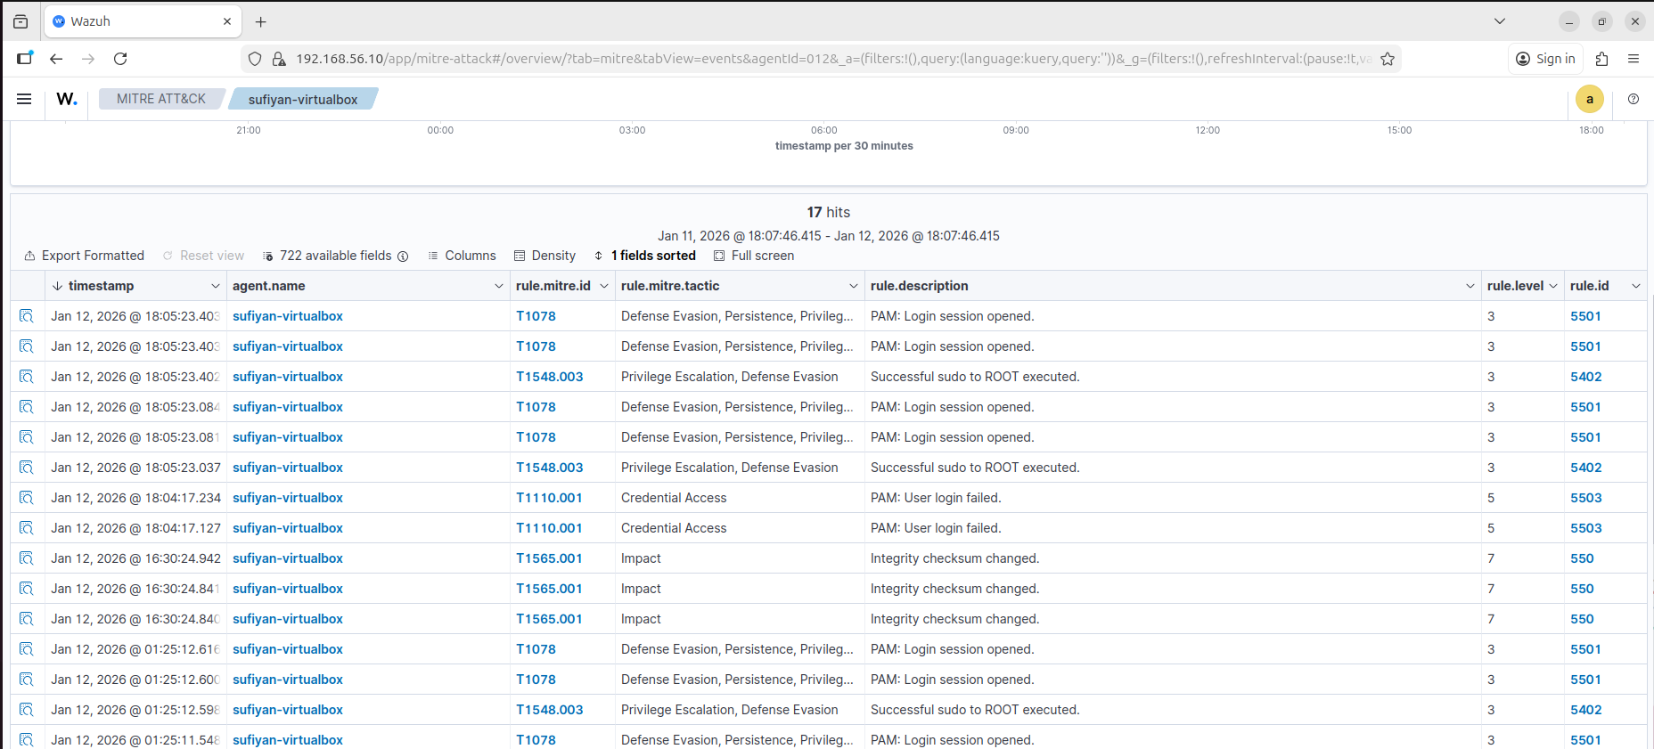

WINDOWS
Wrong login → Event ID 4625
